**RAJALAKSHMI ENGINEERING COLLEGE**

**RAJALAKSHMI NAGAR, THANDALAM – 602 105**



|  |
| --- |
| **CS23A34**  **USER INTERFACE AND DESIGN LAB** |
| **Laboratory Observation Notebook** |

**Name :** Subash Krishnan

**Year/Branch/Section :** II/CSE/D

**Register No. :** 230701345

**Semester :** IV

**Academic Year:** 2024-25

**Ex. No.: 3**

**Register No.: 230701345**  **Name: Subash Krishnan A**  
Shape

**Develop and compare CLI, GUI, and Voice User Interfaces**

**(VUI) for the same task and assess user satisfaction using**

**Python (Tkinter for GUI, Speech Recognition for VUI),**

**Terminal**

**Aim:**

The aim is to develop and compare Command Line Interface (CLI), Graphical User

Interface (GUI), and Voice User Interface (VUI) for the same task, and assess user

satisfaction using Python (with Tkinter for GUI and Speech Recognition for VUI) and

Terminal.

**Procedure:**  
  
**i) CLI (Command Line Interface)** CLI implementation where users can add, view, and remove tasks using the terminal.

tasks = []   
def add_task(task):   
 tasks.append(task)   
 print(f"Task '{task}' added.")   
def view_tasks():   
 if tasks:   
 print("Your tasks:")   
 for idx, task in enumerate(tasks, 1):   
 print(f"{idx}. {task}")   
 else:  
 print("No tasks to show.")

def remove_task(task_number):   
 if 0 < task_number <= len(tasks):   
 removed_task = tasks.pop(task_number - 1)   
 print(f"Task '{removed_task}' removed.")   
 else: print("Invalid task number.")   
def main():   
 while True:   
 print("\nOptions: 1.Add Task 2.View Tasks 3.Remove Task 4.Exit")   
 choice = input("Enter your choice: ")   
 if choice == '1.':   
 task = input("Enter task: ")   
 add_task(task)   
 elif choice == '2.':   
 view_tasks()   
 elif choice == '3':   
 task_number = int(input("Enter task number to remove: ")) remove_task(task_number)   
 elif choice == '4':   
 print("Exiting...")   
 break   
 else:   
 print("Invalid choice. Please try again.")   
   
if **__name__**== "__**main__**":   
 main()

**Output:**  
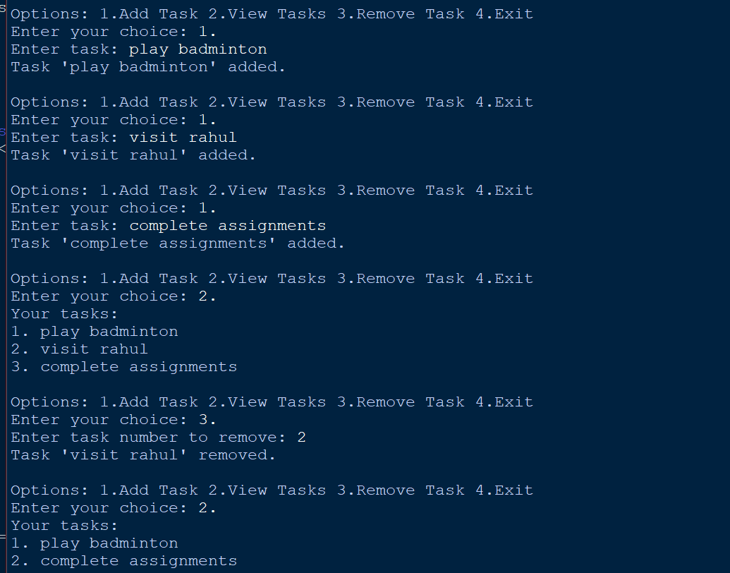

**ii) GUI (Graphical User Interface)**

Tkinter to create a simple GUI for our To-Do List application.

import tkinter as tk   
from tkinter import messagebox   
tasks = []   
def add_task():   
 task = task_entry.get()   
 if task:   
 tasks.append(task)   
 task_entry.delete(0, tk.END)   
 update_task_list()   
 else: messagebox.showwarning("Warning", "Task cannot be empty")   
def update_task_list():   
 task_list.delete(0, tk.END)   
 for task in tasks:   
 task_list.insert(tk.END, task)   
def remove_task():   
 selected_task_index = task_list.curselection()   
 if selected_task_index:   
 task_list.delete(selected_task_index)   
 tasks.pop(selected_task_index[0])   
app = tk.Tk()   
app.title("To-Do List")   
  
task_entry = tk.Entry(app, width=40)   
task_entry.pack(pady=10)  
  
   
  
add_button = tk.Button(app, text="Add Task", command=add_task)   
add_button.pack(pady=5)   
  
remove_button = tk.Button(app, text="Remove Task", command=remove_task) remove_button.pack(pady=5)   
  
task_list = tk.Listbox(app, width=40, height=10)  
task_list.pack(pady=10)   
app.mainloop()

**Output**:  
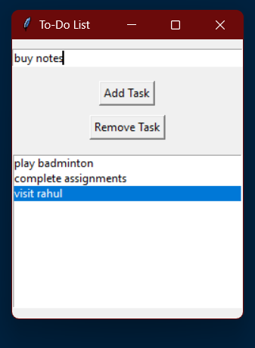

**iii) VUI (Voice User Interface)**

speech_recognition library for voice input and the pyttsx3 library for text-to-speech output. Make sure you have these libraries installed (pip install SpeechRecognition pyttsx3).

import speech_recognition as sr   
import pyttsx3

tasks = []   
recognizer = sr.Recognizer()   
engine = pyttsx3.init()   
  
def add_task(task):   
 tasks.append(task)   
 engine.say(f"Task {task} added")   
 engine.runAndWait()

def view_tasks():   
 if tasks:  
 engine.say("Your tasks are")   
 for task in tasks:   
 engine.say(task)   
 else:   
 engine.say("No tasks to show")   
 engine.runAndWait()   
def remove_task(task_number):   
 if 0 < task_number <= len(tasks):   
 removed_task = tasks.pop(task_number - 1)   
 engine.say(f"Task {removed_task} removed")   
 else:   
 engine.say("Invalid task number")   
 engine.runAndWait()   
def recognize_speech():   
 with sr.Microphone() as source:   
 print("Listening...")   
 audio = recognizer.listen(source)   
 try:   
 command = recognizer.recognize_google(audio)   
 return command   
 except sr.UnknownValueError:   
 engine.say("Sorry, I did not understand that")   
 engine.runAndWait()   
 return None   
def main():   
 while True:   
 engine.say("Options: add task, view tasks, remove task, or exit") engine.runAndWait()  
 command = recognize_speech()   
 if not command:   
 continue   
 if "add task" in command:   
 engine.say("What is the task?")   
 engine.runAndWait()   
 task = recognize_speech()   
 if task:   
 add_task(task)   
 elif "view tasks" in command:  
 view_tasks()   
 elif "remove task" in command:   
 engine.say("Which task number to remove?")   
 engine.runAndWait()   
 task_number = recognize_speech()   
 if task_number:   
 remove_task(int(task_number))   
 elif "exit" in command:   
 engine.say("Exiting...")   
 engine.runAndWait()   
 break   
 else:   
 engine.say("Invalid option. Please try again.")   
 engine.runAndWait()   
if _**name__** == "__**main__**":   
 main ()

**Output:**  
The program initializes the speech recognizer and text-to-speech engine. It then enters a loop where it announces the available options ("add task, view tasks, remove task, or exit").

It listens for your voice input. Depending on what you say:

* If you say **"add task"**, it will ask you, "What is the task?" After you speak your task, it will add the task to a list and announce that the task has been added.
* If you say **"view tasks"**, it will announce all current tasks by enumerating them. For example, if you have one task "buy groceries," it will say "1. buy groceries."
* If you say **"remove task"**, it will ask for the task number to remove. If you respond with a valid number (like "1"), it will remove that task and announce its removal.
* If you say **"exit"**, it will announce "Exiting..." and then terminate the program.
* For any other command, it will announce "Invalid option. Please try again."

**Result:**  
 CLI, GUI, and Voice User Interfaces (VUI) have been developed and compared for the given task and the user satisfaction has been assessed using Python (Tkinter for GUI, Speech Recognition for VUI).